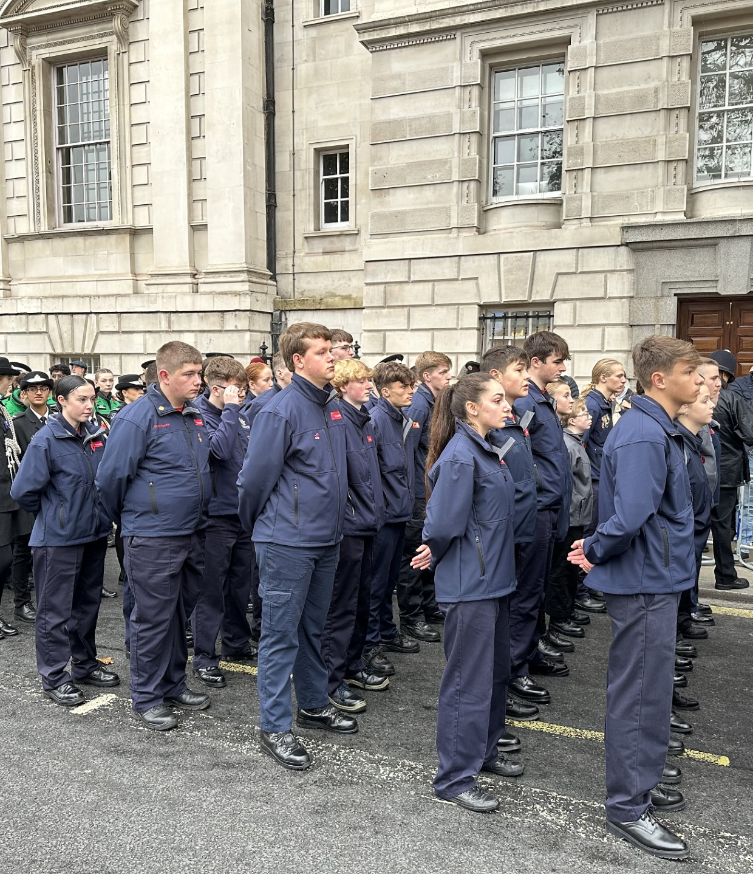
Fire Cadets
National
Framework
2022 - 2025
UK FIRE CADETS’ NATIONAL COLLABORATIVE FRAMEWORK
2022 -2025

UK Fire Cadets is a national collaborative approach to the delivery of uniformed youth provision by UK Fire and Rescue Services supported by the National Fire Chiefs Council

Our intent | UKFC intend to reduce community risk and improve the life chances of young people by working collaboratively to provide safe spaces and better life changing opportunities. Fire Cadets facilitate this by building on the strengths of our young people, supporting them to make positive contributions in their communities, develop social capacity and make positive life choices.

OUR VALUES AND IDENTITY |  | DELIVERING A SERVICE
As a Uniformed Youth Organisation Fire Cadets strive towards a shared set of values, identity and purpose.  Our values:  - Treat each other with fairness and respect  - Act with integrity and honesty  - Challenge prejudice and discrimination  - Be responsible citizens  - Commit to personal development  - Actively seek the views of young people  Our shared identity is:  - An involvement of Young people in decision making  - A programme duration minimum one academic year  - A Core target age 13-17 years of age  - Opportunities for recognition of attainment.  - Participation in social action  - An environment that promotes resilience and safer, stronger communities  - Inclusive and diverse membership  Our organisation consists of:  UKFC Executive – Chair and Vice Chair appointed by the NFCC CYP Lead Officer and supported by staff from the NFCC CYP Team.  UKFC Strategic Hub – Strategic group, chaired by the UKFC Chair, responsible for planning and development with membership drawn from managers within Fire and Rescue Services that deliver uniformed youth provision.  UKFC Network – Membership from staff and volunteers within Fire and Rescue Services that deliver uniformed youth provision. |  | Fire Cadet staff and volunteers will work within the principles and values of the UK Fire and Rescue Service’s Children and Young People Offer.  Our Aims  - To continue to develop as an exceptional uniformed youth organisation shaped by young people, making a positive difference in our communities.  - To ensure the nationally recognised framework continues to grow and reflects the needs and aspirations of young people.  - To contribute to the reduction in community risk and vulnerability.  Our Objectives  - To promote and develop the national brand and shared identity of Fire Cadets.  - To encourage the active involvement of young people in the future development of Fire Cadets.  - To encourage recruitment strategies that consider disadvantaged, under-represented young people and left behind communities.  - To promote opportunities for participation in regional, national and international events and activities.  - To improve the training opportunities available for instructors in line with national good practice.  - To support the provision of quality volunteering opportunities for adults.  - To develop partnerships with agencies and organisation that have similar goals.  - To promote participation in Social Action to increase community engagement and reduce community risk and vulnerability.

